**Project Planning**

**Luca Dixie**

**INFO I360**

**September 8, 2021**

1. **Purpose / Goals / Description**
   1. **Goal**

The goal of my project website is to display all of the technical skills I have learned so far during my college career. The main skills I would wish to display on my website are related to my programming and graphic design work, along with the website itself being an example of my skills with HTML and CSS. Depending on the scale of the project and time restraints, I may not include my examples of work in Python and C# (through Unity Engine). However, if I find a way to implement pieces of code in my website, I will definitely incorporate that in my design.

* 1. **Purpose**

Beyond this project, I would like to use this site as my own portfolio to continuously improve and update on. When I graduate, I would most likely like to get into graphic design work, but I would also include my programming experience for the possibility of getting into a web design career.

* 1. **Description**

The image I have in mind for the project is one that I want the website to reflect my skills and personality as an aspiring graphic designer. There will be more images than text throughout the whole website, with an exception to the “Resume” and “About Me” sections. I want to incorporate colors and typography that give off a modern style, with brighter colors. However, I will find ways to chose color and text choices where it still gives off a professional tone.

1. **Organization / Layout**

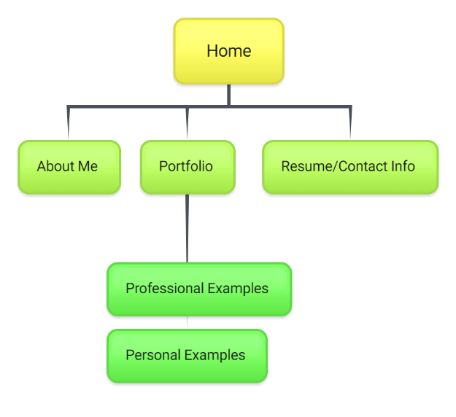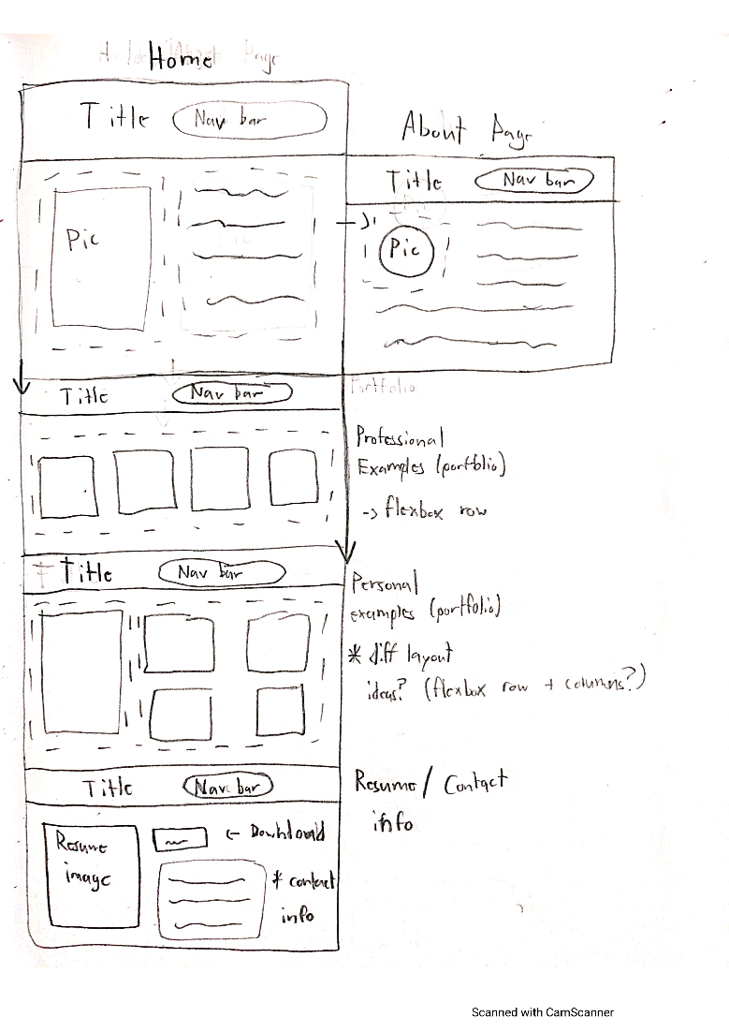

1. **Content / Resources**
   1. **Content**

Most of the content on my site will be of my own creation, therefore most outside sources will be used in the structure of the website itself. The main content that will be used from an outside source would be fonts from Google. Fontpair will be the main tool I use to determine which fonts I will use. While not directly being used within the site, I will also decide my color palettes through tools such as Coolers and Abode Color.

* 1. **Resources**

I’m planning on Flexbox is a main resource, I will use in building the site, with the possibility of using Bootstrap functions. I often look to sites such as W3Schools and Stack Overflow when I’m not sure how to accomplish a certain action or effect I want. I will also use the HTML and CSS validator to make sure that files would be ready for being shared on the web.

1. **Branding / Look & Feel**
   1. **Branding**

The “brand” for my website would be me advertising myself to potential employers. In that regard, I want to be able to show some of my personality while also remaining professional. I want to be able to mainly display my creativity through the site’s design itself, and in the graphic design examples I will have on my website. I want to incorporate “flashy” features such as animated buttons, but not too much to where it gets overbearing.

* 1. **Look & Feel**

I want my website to have a look where it feels modern as well as professional. The colors I want to lean towards will be brighter than what is expected of a professional site, but I will be sure to use the brighter colors more as accents rather than the base color scheme of the pages.

